**Capstone Project:**

**My Movie Plan**

**Document contains:**

* Project and developer details
* Sprints planned and the tasks achieved in them
* Core concepts used in the project
* Links to the GitHub repository to verify the project completion

**Project and developer details**

**DESCRIPTION**

Create a dynamic and responsive for booking movie tickets online for different genres and languages.

Background of the problem statement:  
NMS Cinemas is a chain of single screen theatres that screen movie shows of different genres and languages at very genuine prices. It was established in 2004 in Pune, India. Recently, the business analysts noticed a decline in sales since 2010. They found out that the online booking of movie tickets from apps, such as Book My Show and Paytm were gaining more profit by eliminating middlemen from the equation. As a result, the team decided to hire a Full Stack developer to develop an online movie ticket booking web application with a rich and user-friendly interface.  
You are hired as the Full Stack Java developer and are asked to develop the web application. The management team has provided you with the requirements and their business model so that you can easily arrange different components of the application.

Features of the application:

1. Registration
2. Login
3. Payment gateway
4. Searching
5. Filtering
6. Sorting
7. Dynamic data
8. Responsive and compatible with different devices

**Admin Portal:**

It deals with all the backend data generation and product information. The admin user should be able to:

* Add or remove different genres to or from the application to build a rich product line
* Edit movie details like name, ticket price, language, description, and show timings to keep it aligned to the current prices
* Enable or disable the movie shows from the application

**User Portal:**

It deals with the user activities. The end-user should be able to:

* Sign-in to the application to maintain a record of activities
* Search for movie tickets based on the search keyword
* Apply filters and sort results based on different genres
* Add all the selected movie tickets to a cart and customize the purchase at the end
* Experience a seamless payment process
* Receive a booking summary page once the payment is complete

**Developer Details**: Sadhu Venkata Sai Kumar

svsai97@gmail.com

7780556763

**Sprints planned and the tasks achieved in them**

There are four sprints for this project

Sprint-1: Studied the Features of application and created Git Repository.

Sprint-2: My Movie Plan backend created using spring boot and tested backend API

Sprint-3: My Movie Plan frontend created using spring boot and connected with backend.

Sprint-4: My Movie Plan application all features is tested.

**Recommended technologies**

Database management: MySQL

Backend development: Java programming, Eclipse, Spring Boot

Frontend development: JSP, Angular, Bootstrap, HTML/CSS.

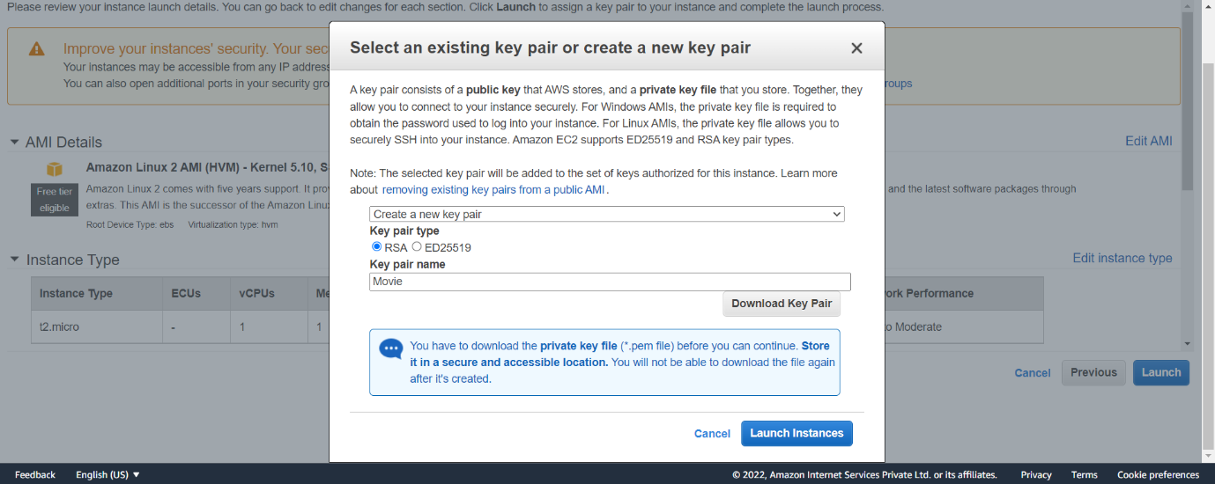

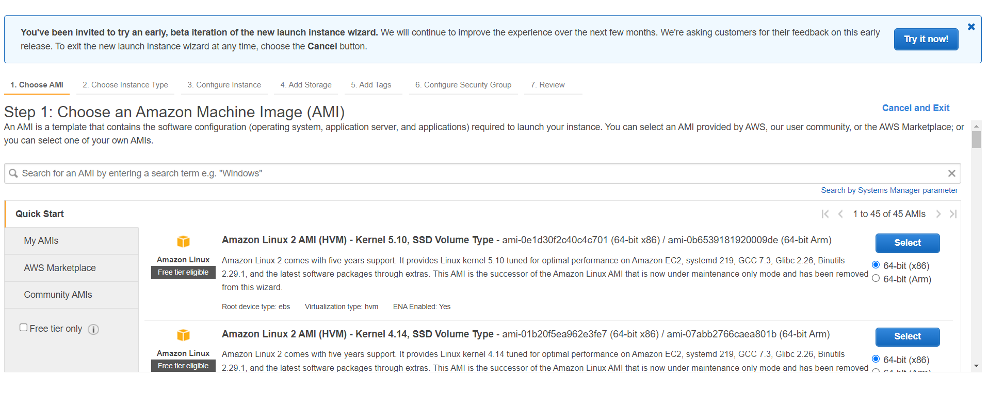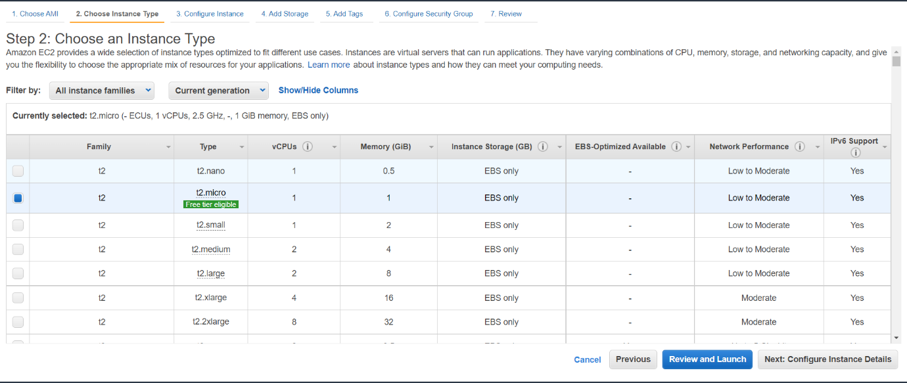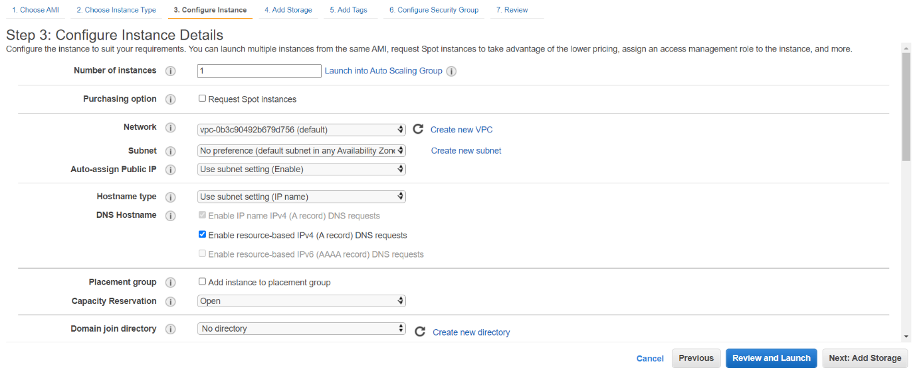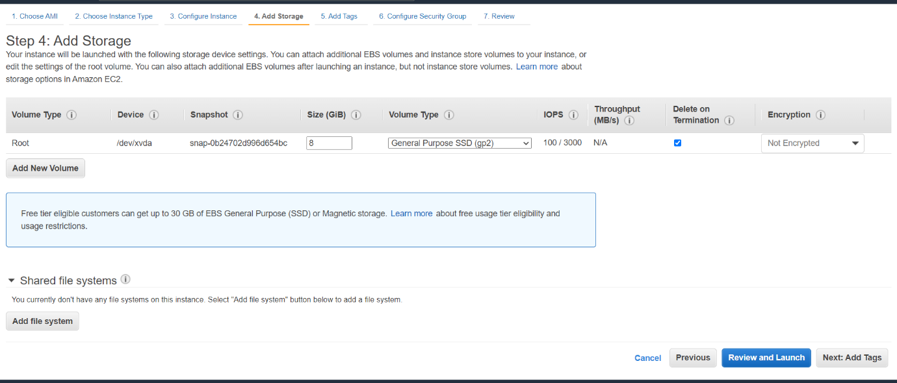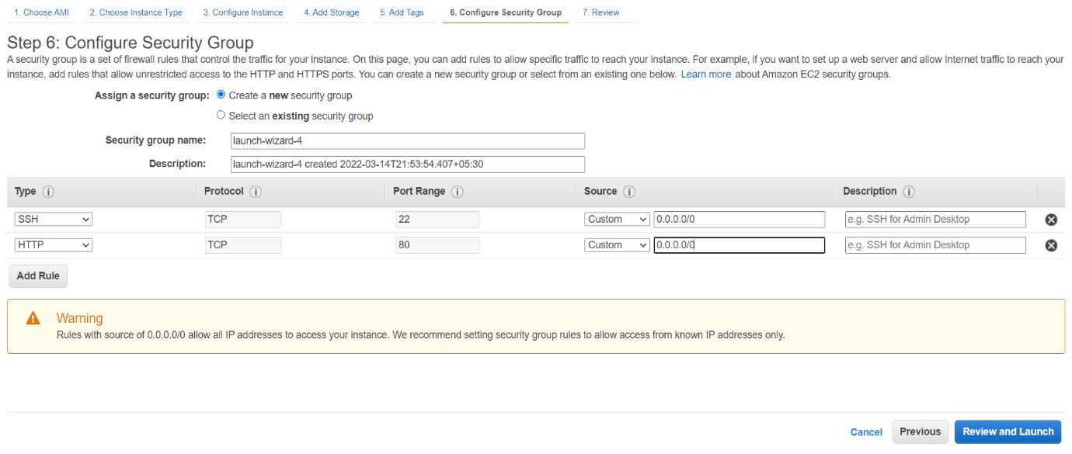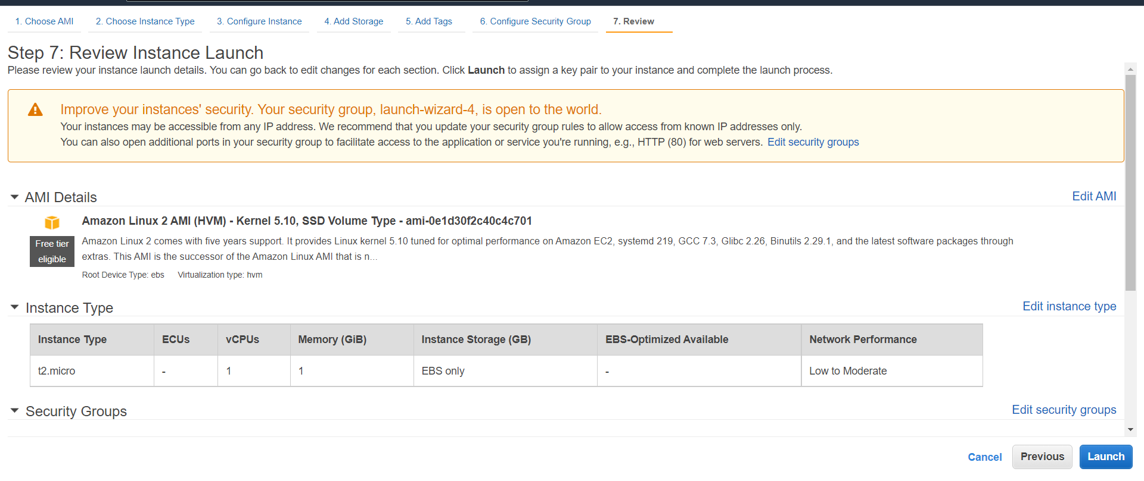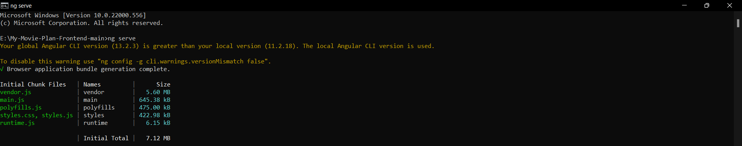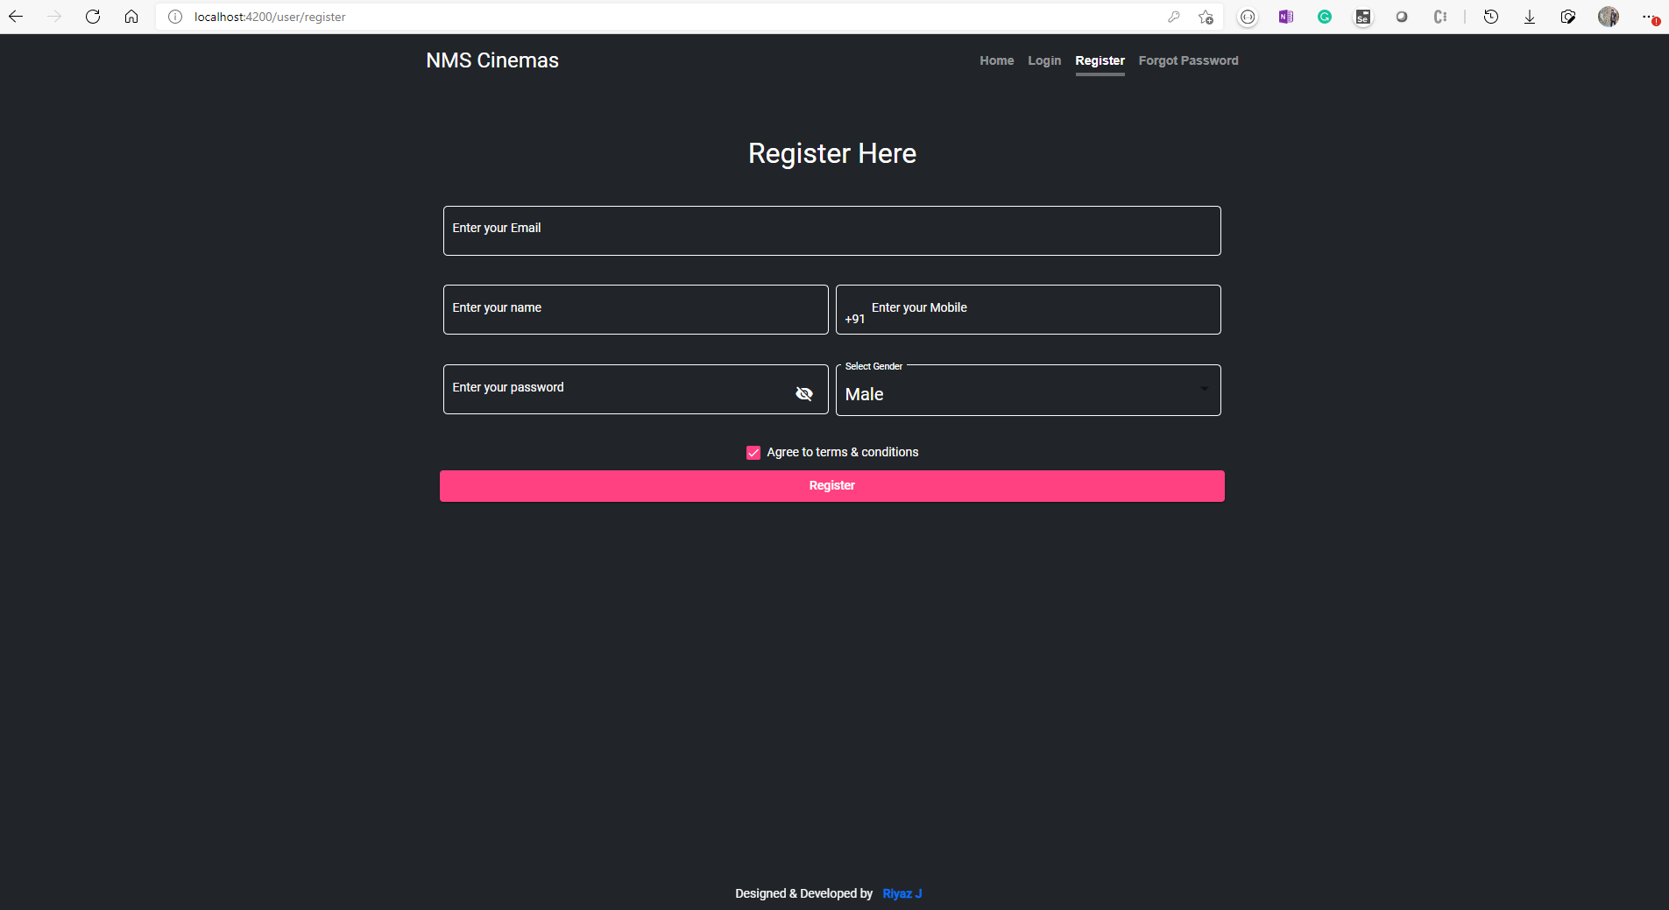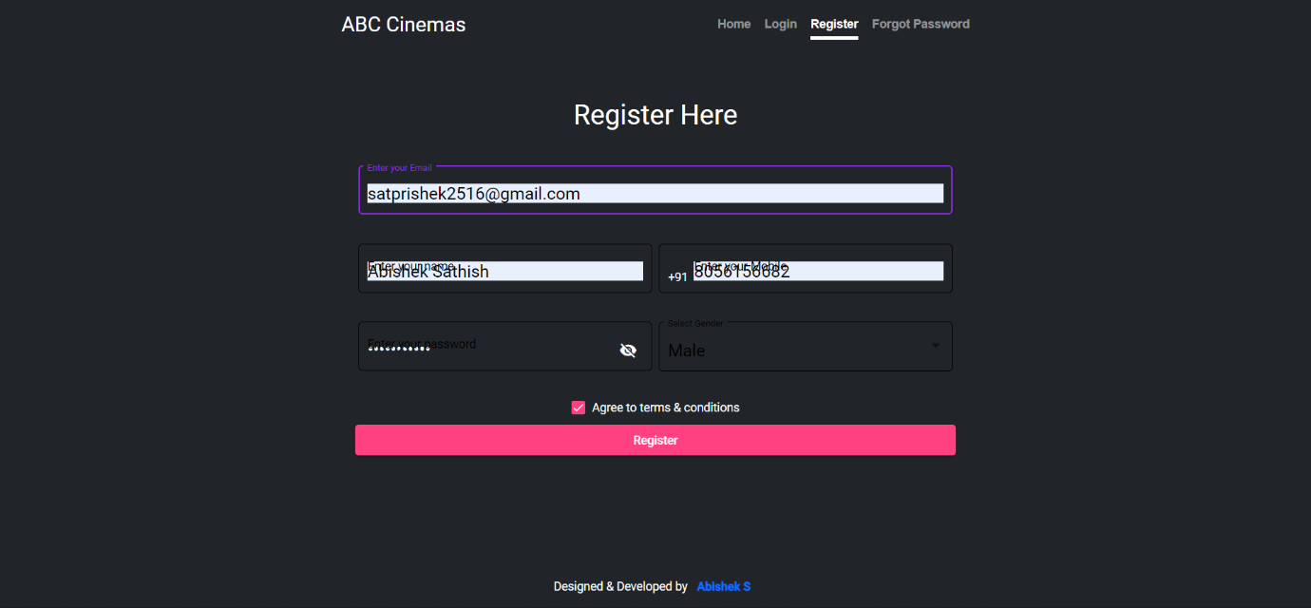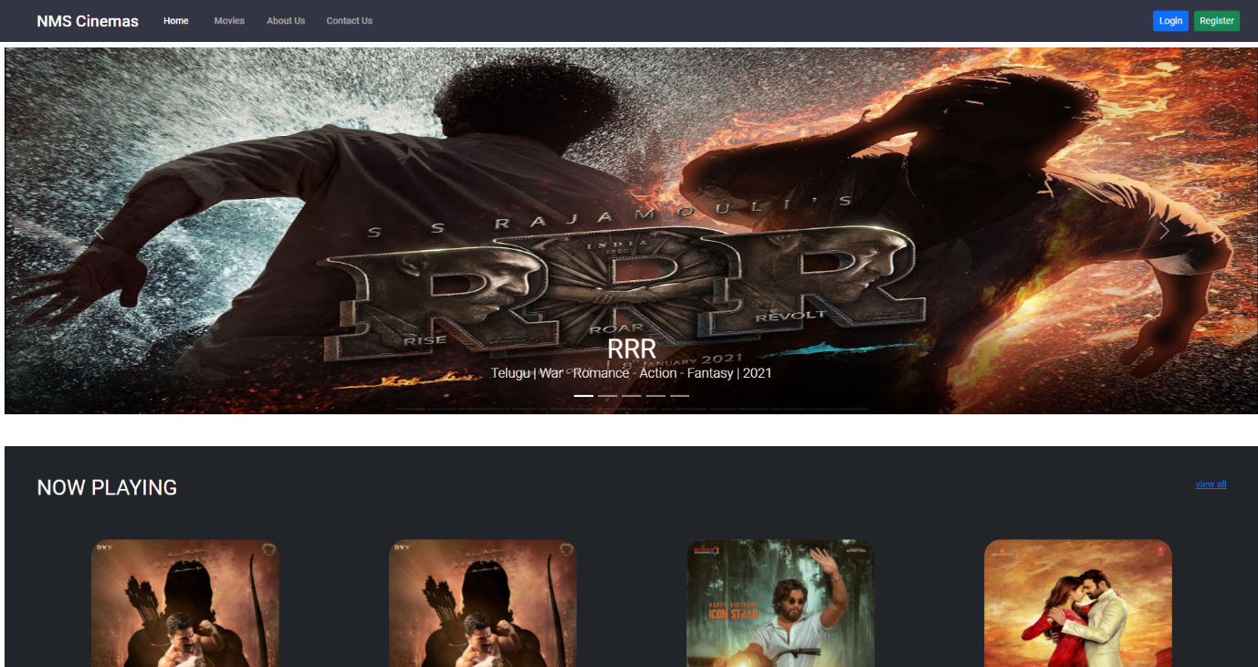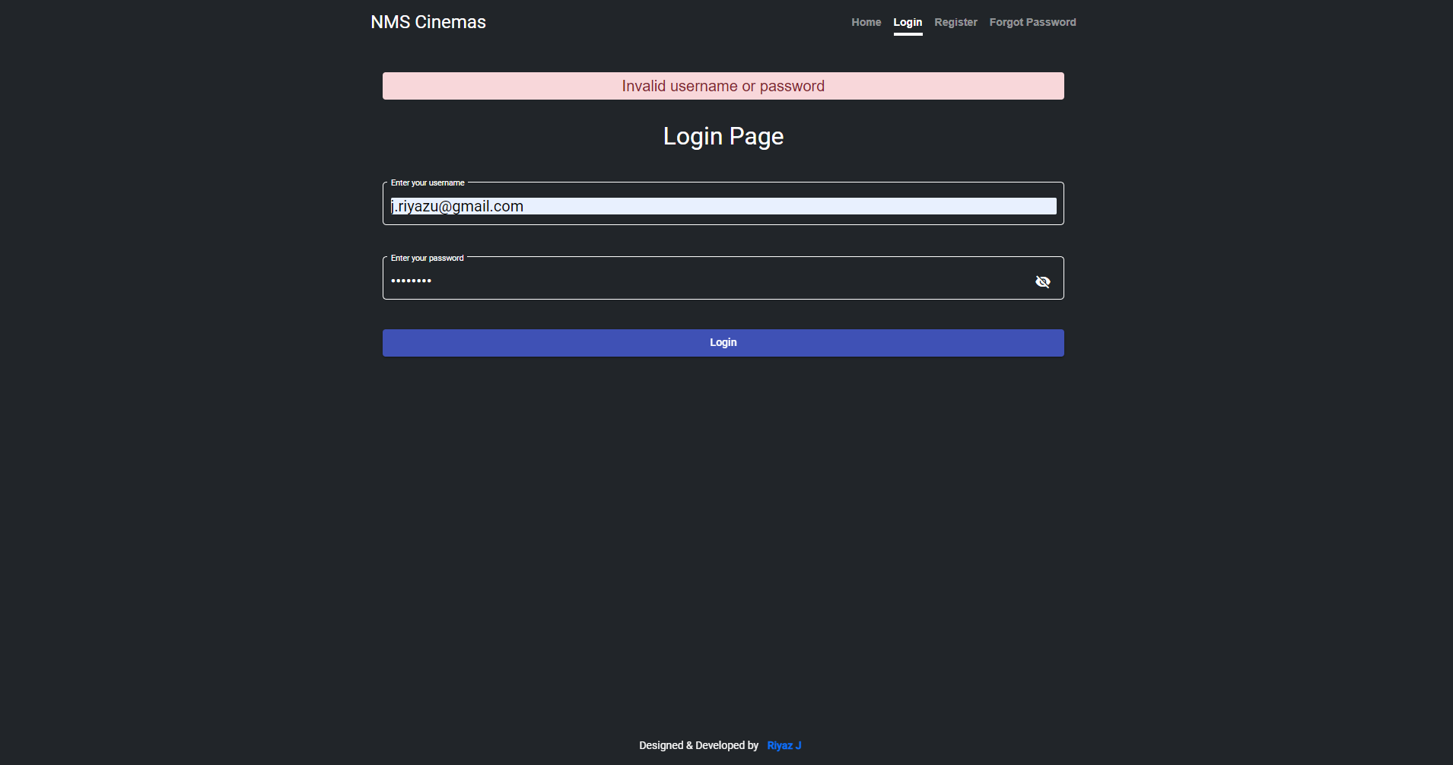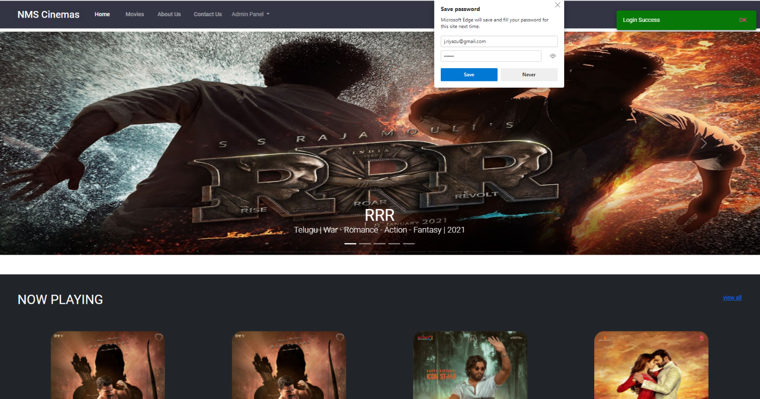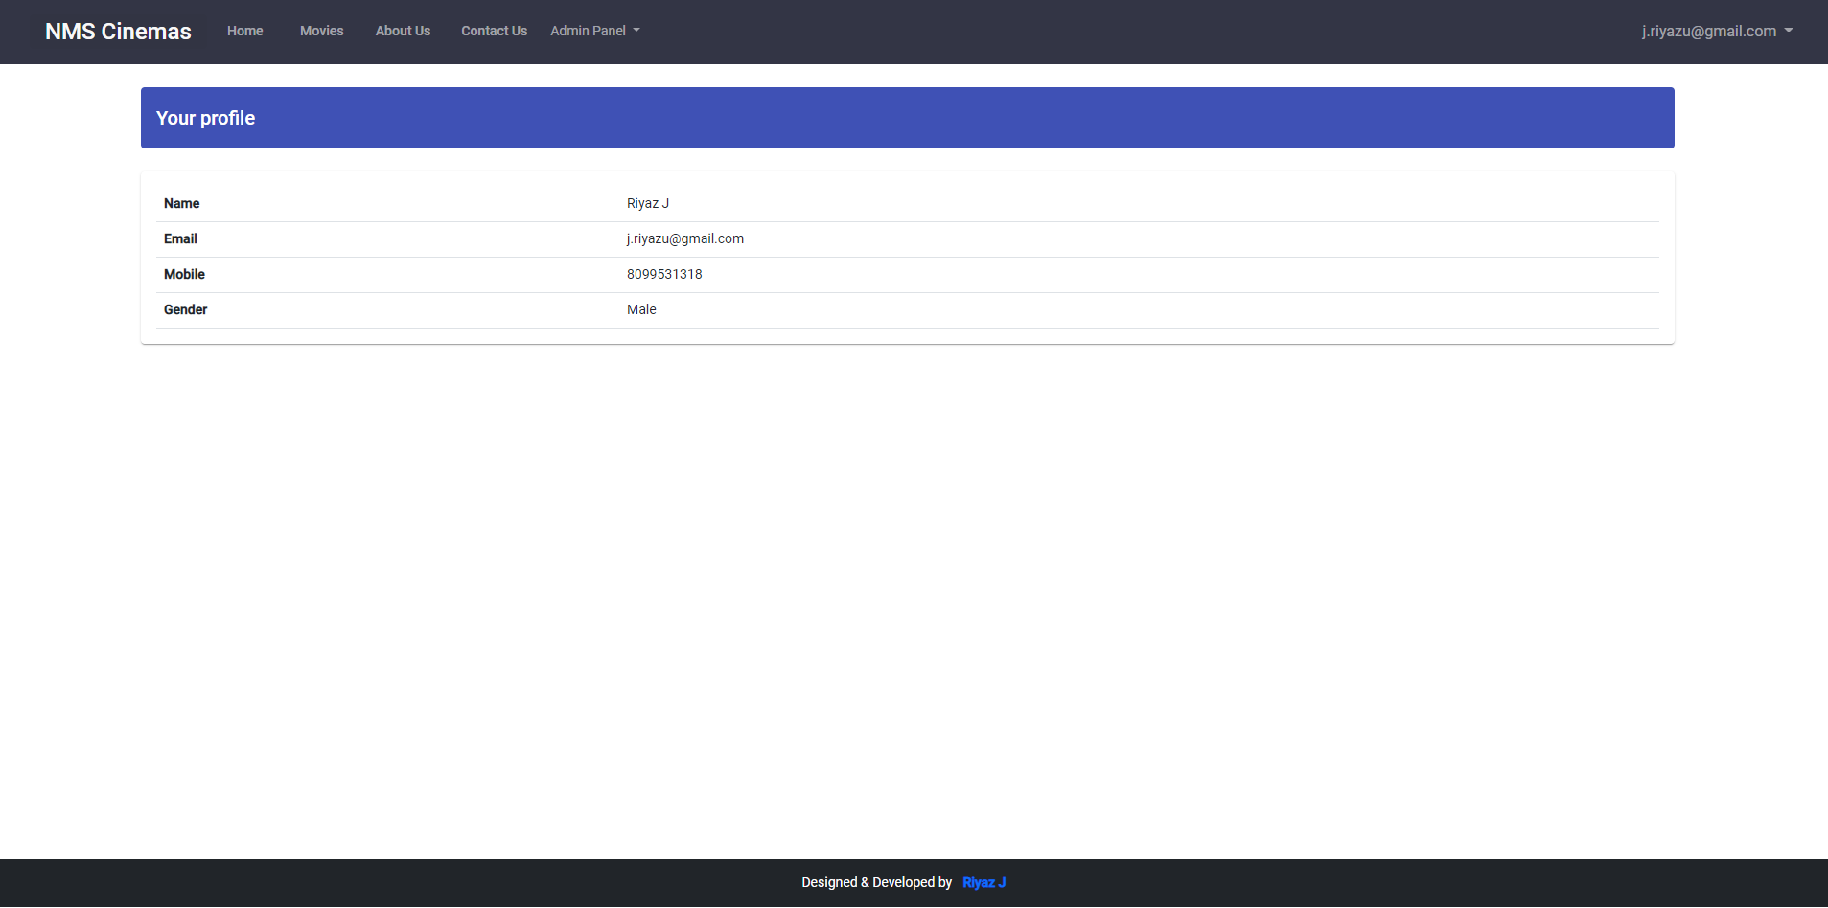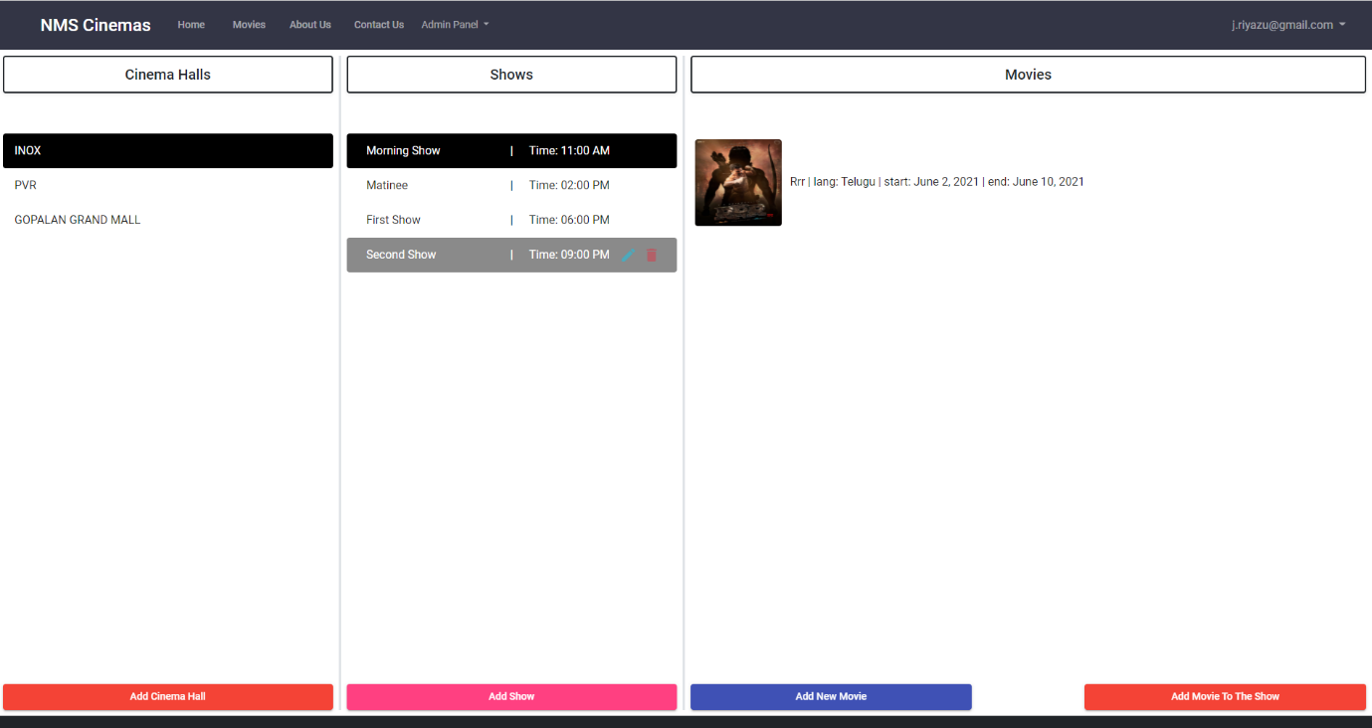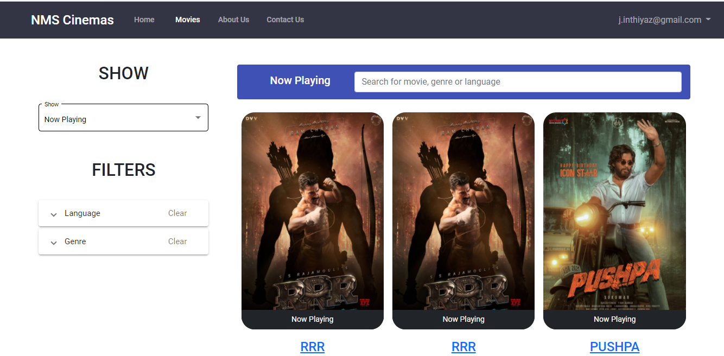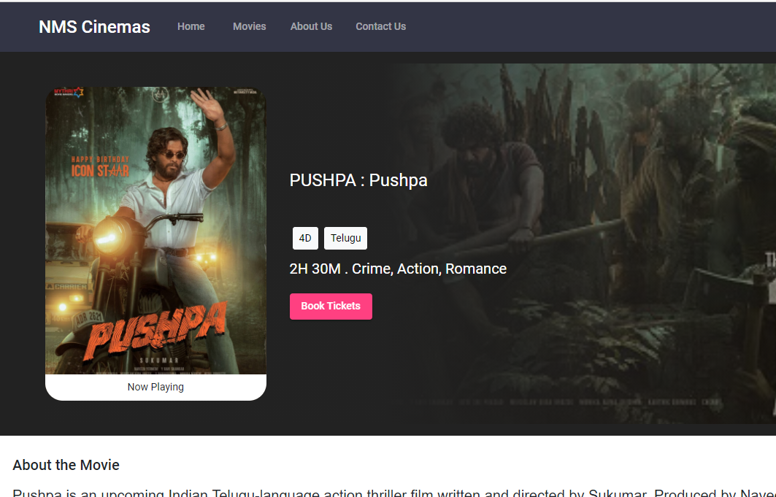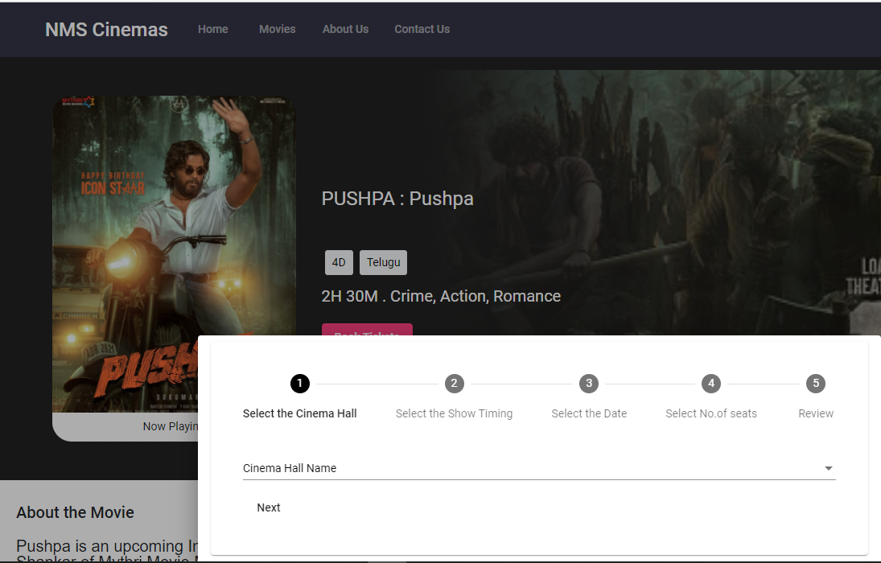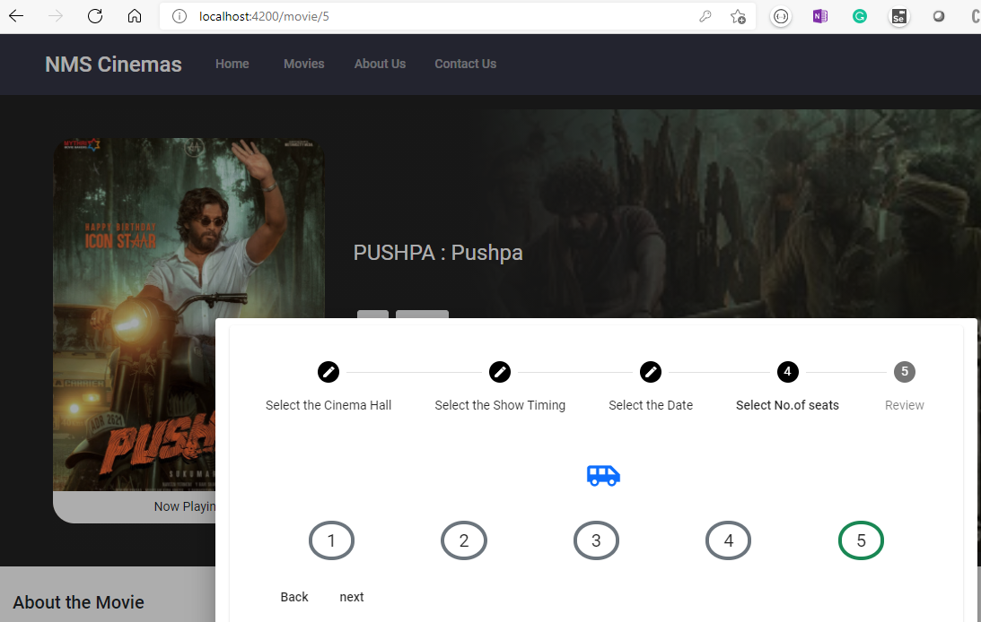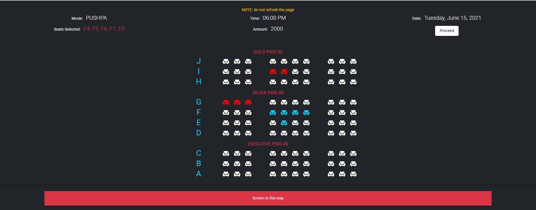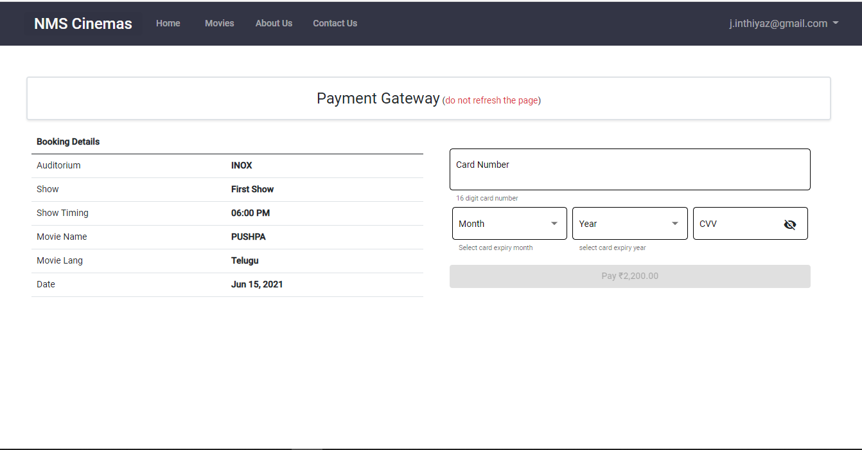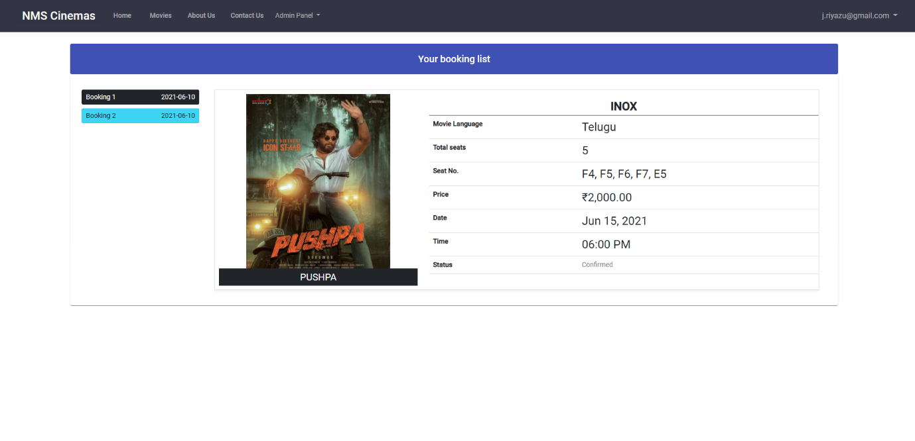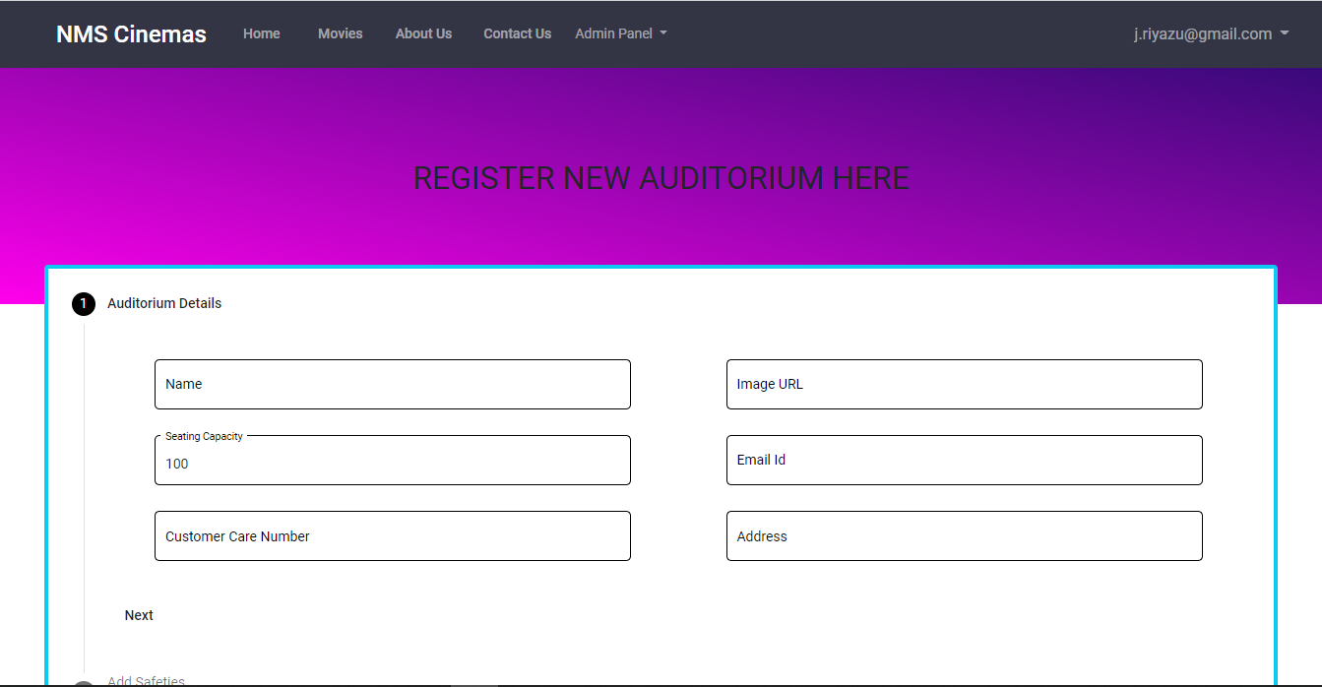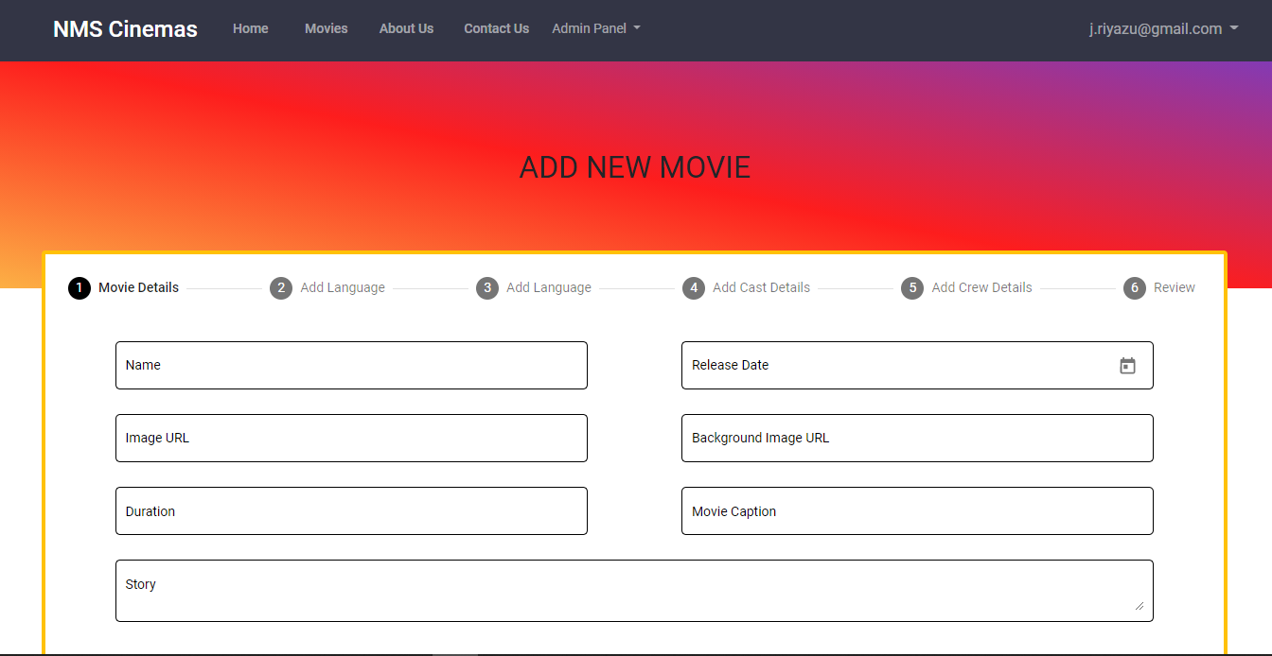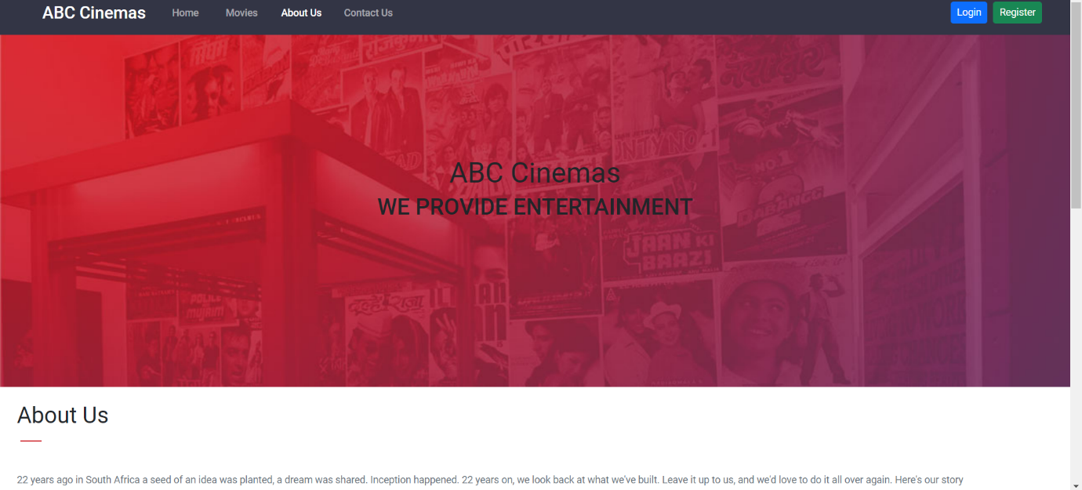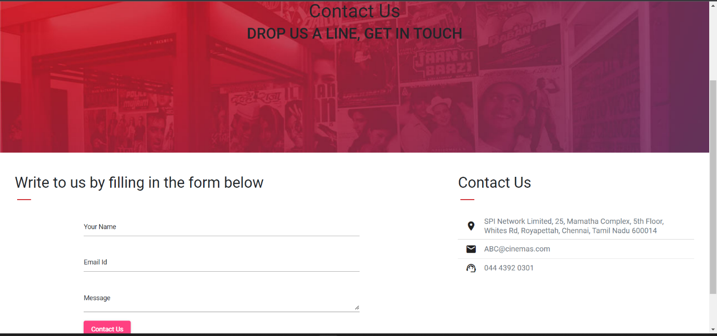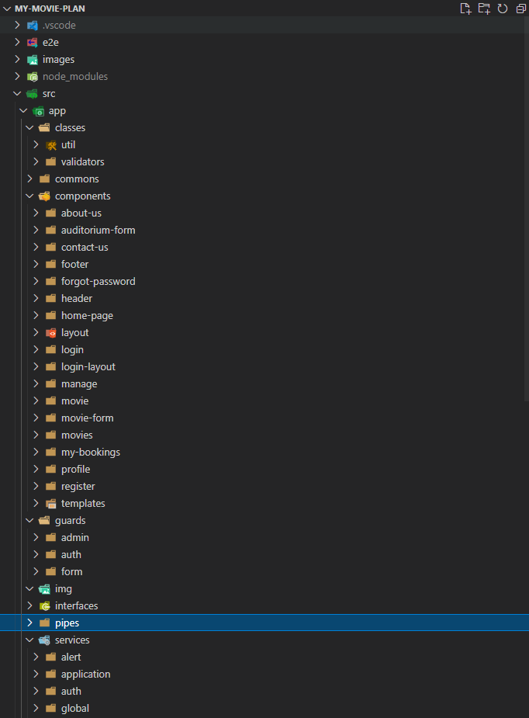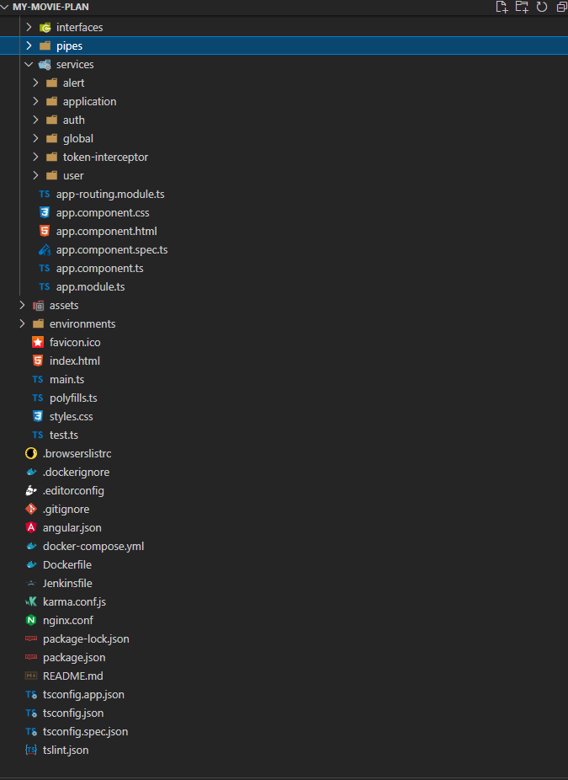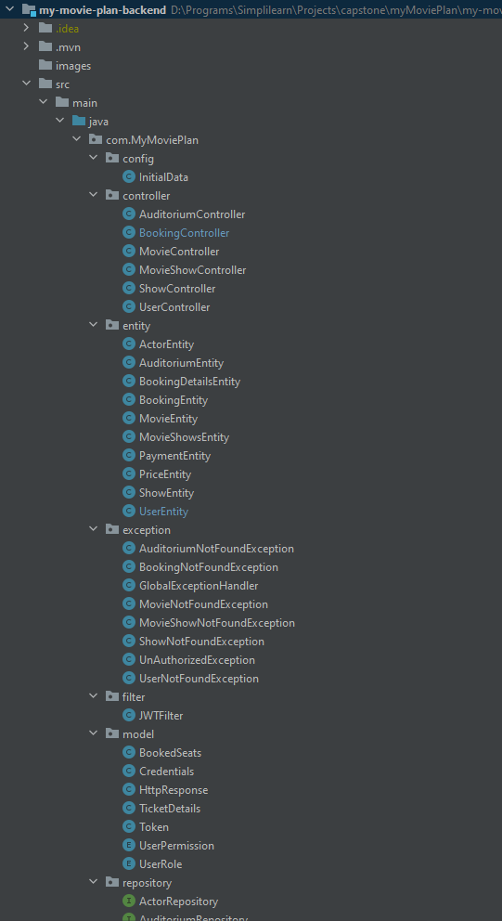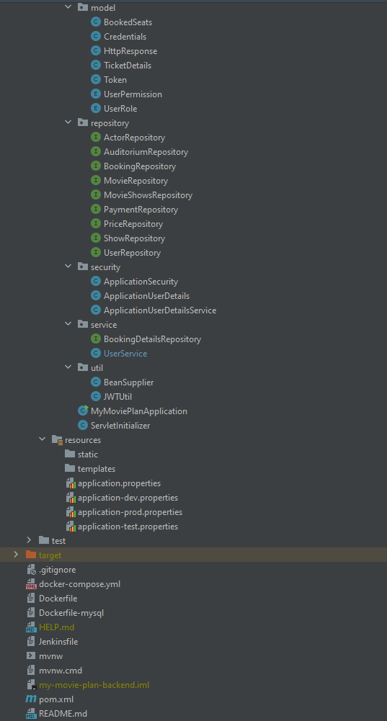

**Links to the GitHub repository to verify the project completion**

For source code please use GitHub link.

[**https://github.com/Svsai97/MyMoviePlan_CapstoneProject.git**](https://github.com/Svsai97/MyMoviePlan_CapstoneProject.git)